

SCCM/CSForm/Rev. Ver 2.0

*Please tick* ✓

✓

**For office use only** - Lecturer comments: **Breakdown**

Signature: **Total**

**Name : Chan Hui Ni  
Student ID: 0125127  
Email : 0125127@kdu-online.com  
Mobile No: 0127995838 Signature:  
Date: 22.7.2019**

**Name :  
Student ID:  
Email :  
Mobile No: Signature:  
Date:**

FOUNDATION DIPLOMA DEGREE

Assignment Coversheet **Please complete all details required clearly.** For softcopy submissions,please ensure this cover sheet is included at the start of your document or in the file folder.

**Assignment & Course Details:**

|  |  |  |  |
| --- | --- | --- | --- |
| **Module Code:** *(e.g. GCAS100)* | XDCS 1104 | **Module Name** *(e.g. Fundamentals of Computing*)**:**  VB.Net Programming | |
| **Course Name** *(e.g. Bachelor in Computing)* :  Diploma in Computer Studies | | | |
| **Name of Lecturer:** Dr.Law Foong Li | | | |
| **Assignment Due Date:** *(dd/mm/yy)* | 22 July 2019 | **Assignment Title:** | VB Group Assignment |

**Student/s details:**

**Name :  
Student ID:  
Email :  
Mobile No: Signature:  
Date:**

**Name :  
Student ID:  
Email :  
Mobile No: Signature:  
Date:**

**Name :  
Student ID:  
Email :  
Mobile No: Signature:  
Date:**

**Name : Ong Wei Wei  
Student ID: 0125555  
Email : 0125555@kdu-online.com  
Mobile No: 0135875260 Signature:  
Date: 22.7.2019**

*I/We declare that:*

* *This assignment is my/our own original work, except where I/we have appropriately cited the original source.*
* *This assignment or parts of it has not previously been submitted for assessment in this or any other subject.*
* *I/We allow the assessor of this assignment to test any work submitted by me/us, using text comparison software for plagiarism.* ***(For more information, Please read the Academic Integrity Guidelines)***

**Table Content**

Use Case Diagram ……………………………………………………………………… 3 - 4

Entity Relationship Diagram ………………………………….……………...……….... 5 - 6

Implementation – User Manual ………………………………………..……………... 7 - 16

Marking scheme …………………………………………………………………….... 17 - 22

Draft ……………………………………………………………………………………. 23 - 25

Log files …………………………………………………………………………….…….…. 26

**Use Case Diagram**

**Entity Relationship Diagram**

**User Manual**

1. There is two type of account. To log in as an admin, the correct username and password for admin is needed.

1. After logging in, users will be directed to the admin page which allows the admin to select the categories they want to access. There are 3 categories - Menu, Employee and Customer. Admin can also press log out to exit back to the log in page.

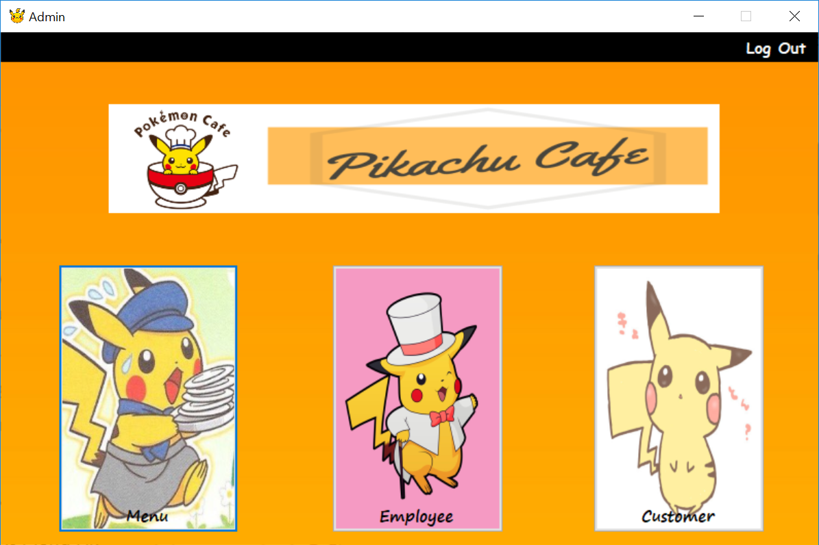

1. If the admin has select the Menu button, the page will load the database of the foods and drinks for admin to view the database.

1. The admin can then press the edit database button to edit the data inside the database. There is also a return button that allows the admin return to the last page. Admin can choose to add, delete or update the food and drink database by clicking the button on the menu bar.

1. If the admin chooses the employee category, the admin will be directed to a page which they can view the database of the employee. There is also a back button which will return to the previous page.

1. After pressing the edit database button, the admin can add, update or delete the data in the employee database. The return button can also be pressed to return to the page to view the employee database. The password of the employee can be edited in this page in case they forgot about their password.

1. If the admin clicks on the customer button, a page with the database of the customers will be loaded. There is a return button provided that allows the admin to return the main page.

1. After admin click on the edit database button, it will show the page that allows the admin to edit the database of the customers. Customers who are not a member will have a null field in the member id column.

1. Another type of account is employee. To log in as an employee, the employee needs to key in their name and password.

1. After logging in as an employee, the daily special page will be shown. The pictures inside the daily special page will be different every time the employees log in.

1. Then employee can then click on the menu button to view the list of the foods and drinks. The employee can order either the food or the drink by increasing the quantity of the food with the numeric up down tool. After finishing an order, the employee can click on the cart button at the right side of the menu which will direct the employee to the list of food ordered.

1. After clicking on the cart button, the employee can view the list of food ordered before confirming an order. The employee need to key in the customer ID before pressing the confirm button to confirm whether the customer is a member or not. The total amount of the order will be shown at the bottom of the page in a textbox. The employee can also press the return button if the customer orders another food or drink.

1. After pressing the confirm button, the receipt for that order will be generated. If the customer is not a member, they will not receive any discount. The order id will be shown at the top of the receipt. The amount that the customer need to pay will be calculated and displayed in the receipt. The time of the payment will also be displayed at the bottom of the receipt.

1. If the customer is a valid member, they are entitled to 20% discount of the total price of their order. The receipt will be generated with the total price, service charge, discount value and the amount customer need to pay. The employee can right click on the page with their mouse to print out the receipt.

**Marking Scheme**

|  |  |  |
| --- | --- | --- |
| **Part 1 – Use Case Diagram (10%)** | | |
| Description | Marks | Actual Mark Awarded |
| Excellent in the areas of the scope, actors, use cases, relationships, consistency and syntax. Appropriate actors are identified. The actors have been allocated appropriate responsibilities. Use cases are sensibly named. The scope of the system appears reasonable. Correct UML syntax is employed including sensible use of stereotypes. The diagram covers most of the expected aspects but has minor errors or oversights. For example there may be minor errors of syntax, or occasional unusual naming of elements, or minor additions, or omissions in scope may have occurred, or minor presentation problems, or minor issues of use case granularity. More or fewer actors than expected may have been identified. Overall an excellent use case diagram. | 16-20 |  |
| Good in the areas of the scope, actors, use cases, relationships, consistency and syntax. The diagram is covers most of the expected aspects but has errors or oversights. For example there may be errors of syntax, or unusual naming of elements, or additions or omissions in scope may have occurred, or issues of use case granularity, or presentation problems. Alternatively there may be a number of minor issues which prevent the diagram from being excellent. Overall a good use case diagram. | 13-15 |  |
| Satisfactory in the areas of the scope, actors, use cases, relationships, consistency and syntax. A reasonable attempt has been made however the number and significance of the errors prevent the diagram from being good. The diagram is however recognizable as a use case diagram and the scope of the system is reasonable. Overall a satisfactory use case diagram. | 10-12 |  |
| Weak in the areas of the scope, actors, use cases, relationships, consistency and syntax. An attempt has been made; however the number and significance of the errors make the diagram poor, but still usable. The diagram is recognisable as a use case diagram of the proposed system. Overall a poor use case diagram. | 8-9 |  |
| Unsatisfactory diagram in the areas of the scope, actors, use cases, relationships, consistency and syntax. Either the diagram is not recognisable as a use case diagram or the content is seriously flawed, or both. Overall an unsatisfactory use case diagram. | 0-7 |  |
| Comments |  |  |
| Total | |  |
| **Part 2 – Entity Relationship (ER) Diagram (20%)** |  |  |
| Description | Marks | Actual Mark Awarded |
| Excellent in the areas of the scope, entities, attributes, relationships, consistency and syntax. The correct scope is modelled covering all the requirements. Entities are sensibly named. Appropriate attributes and relationships are allocated to entities. An appropriate and complete set of attributes has been identified. An appropriate and complete set of relationships has been identified. Plausible relationships including types, names and multiplicity. Correct following of crow feet notation standards. The diagram is consistent. Any errors, omissions or additions are very minor. Overall an excellent ER diagram. | 16-20 |  |
| Good in the areas of the scope, entities, attributes, relationships, consistency and syntax. It is possible that the diagram is outstanding or excellent in some areas and satisfactory in others but on balance is good. Satisfactory or above in all areas. Likely to contain a small number of errors, omissions or additions which prevent the diagram from being excellent. Overall a good ER diagram. | 13-15 |  |
| Satisfactory in the areas of the scope, entities, attributes, relationships, consistency and syntax. It is possible that the diagram is good or above in some areas and satisfactory in others. Weak in no more than two areas. Likely to contain a number of errors, omissions or additions which prevent the diagram from being good. Overall satisfactory. | 10-12 |  |
| Weak in the areas of the scope, entities, attributes, relationships, consistency and syntax. It is possible that the diagram is satisfactory or above in some areas and unsatisfactory in others. Likely to be weak in more than three areas. It might be unsatisfactory in one area but no more. Likely to contain errors, omissions, additions, or misunderstandings which prevent the diagram from being satisfactory. Overall poor. | 8-9 |  |
| Unsatisfactory diagram in the areas of the scope, entities, attributes, relationships, consistency and syntax. It is possible that the diagram is weak or above in some areas and unsatisfactory in others. Unsatisfactory in two or more areas. Likely to contain errors, omissions, additions, or misunderstandings which prevent the diagram from being weak. May not be recognisable as a ER diagram, might have majors errors in content or a combination of the two. | 0-7 |  |
| Comments |  |  |
| Total | |  |
| **Part 3 – Implementation (60%)** |  |  |
| Excellent in the implementation, comments, indentation, consistency and syntax. The work shows particular insight or originality in its approach. Excellent functionalities which identifies the underlying principles behind the problem. All areas are at least good. May be outstanding is some areas and good in others and hence is on balance excellent. Good or above in all areas. Likely to contain minor errors, omissions or additions which prevent the implementation from being outstanding. Overall an excellent implementation. | 16-20 |  |
| Good in the implementation, comments, indentation, consistency and syntax. It is possible that the application is outstanding or excellent in some areas and satisfactory in others but on balance is good. Satisfactory or above in all areas. Likely to contain a small number of errors, omissions or additions which prevent the implementation from being excellent. Overall a good implementation. | 13-15 |  |
| Satisfactory in the implementation, comments, indentation, consistency and syntax. It is possible that the application is good or above in some areas and satisfactory in others. Likely to be weak in no more than two areas. Likely to contain a number of errors, omissions or additions which prevent the implementation from being good. Overall a satisfactory implementation. | 10-12 |  |
| Weak in the implementation, comments, indentation, consistency and syntax. It is possible that the application is satisfactory or above in some areas and unsatisfactory in others. Likely to be weak in more than three areas. It might be unsatisfactory in one area but no more. Likely to contain errors, omissions, additions, or misunderstandings which prevent the implementation from being satisfactory. Still recognisable as an object-oriented application of the problem in focus. Overall poor but satisfactory. | 8-9 |  |
| Unsatisfactory in the implementation, comments, indentation, consistency and syntax. It is possible that the application is weak or above in some areas and unsatisfactory in others. Unsatisfactory in two or more areas. Likely to contain errors, omissions, additions, or misunderstandings which prevent the implementation from being weak. May not be recognisable as an object-oriented application, might have majors errors in implementation or a combination of the two. | 0-7 |  |
| Comments |  |  |
| Total | |  |
| **Part 4 – Presentation (10%)** |  |  |
| Excellent in the presentation and handling all questions. The explanation and justification of how it meets specified requirements shows outstanding insight into the issues involved and alternatives available. The presentation clearly and concisely demonstrates a deep understanding of the project implementation. May be outstanding is some areas and good in others and hence is on balance excellent. Good or above in all areas. Likely to contain minor errors, omissions or additions which prevent the presentation from being outstanding. Overall an excellent implementation. | 8-10 |  |
| Good in the presentation and handling all questions with some minor inaccurate answers. The explanation and justification of how it meets specified requirements shows good understanding into the issues involved and alternatives available. The presentation demonstrates a good understanding of the project implementation. It is possible that the presentation is outstanding or excellent in some areas and satisfactory in others but on balance is good. Satisfactory or above in all areas. Likely to contain a small number of errors, omissions or additions which prevent the presentation from being excellent. Overall a good presentation. | 7 |  |
| Satisfactory in the presentation and handling most of the questions with some inaccurate answers. The explanation and justification of how it meets specified requirements covers relevant aspects into the issues involved and alternatives available, but is not outstanding in any respect. It is possible that the presentation is good or above in some areas and satisfactory in others. Likely to be weak in no more than two areas. Likely to contain a number of errors, omissions or additions which prevent the presentation from being good. Overall a satisfactory presentation. | 5-6 |  |
| Weak in the areas of the presentation and handling some of the questions but most answers are inaccurate. The explanation and justification of how it meets specified required is inadequate. It is possible that the presentation is satisfactory or above in some areas and unsatisfactory in others. Likely to be weak in more than three areas. It might be unsatisfactory in one area but no more. Likely to contain errors, omissions, additions, or misunderstandings which prevent the presentation from being satisfactory. Overall poor but satisfactory. | 4 |  |
| Unsatisfactory in the areas of the presentation and handling all questions and not able to answer any questions posed. It conveys little understanding of solution of the problem or no useful explanation and justification of how it meets specified requirements. It is possible that the presentation is weak or above in some areas and unsatisfactory in others. Unsatisfactory in two or more areas. Likely to contain errors, omissions, additions, or misunderstandings which prevent the presentation from being weak. | 0-3 |  |
| Comments |  |  |
| Total | |  |
| Overall mark | |  |

**Draft**

**Use Case Diagram**

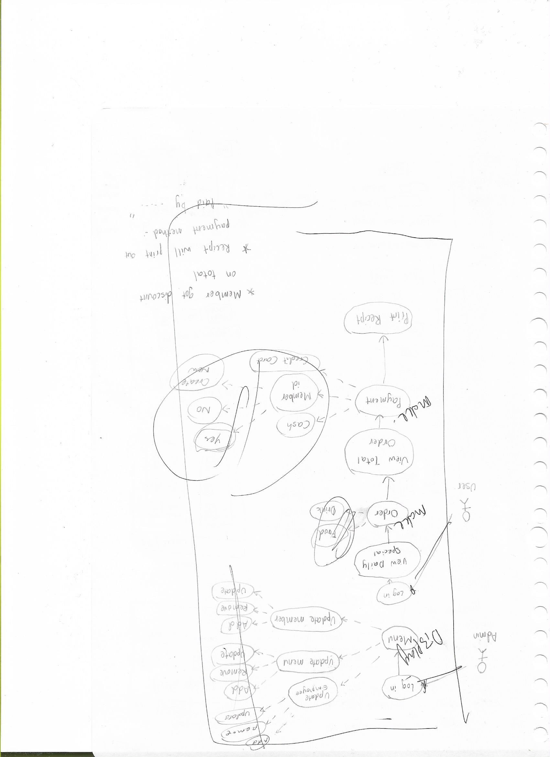

**ER Diagram**

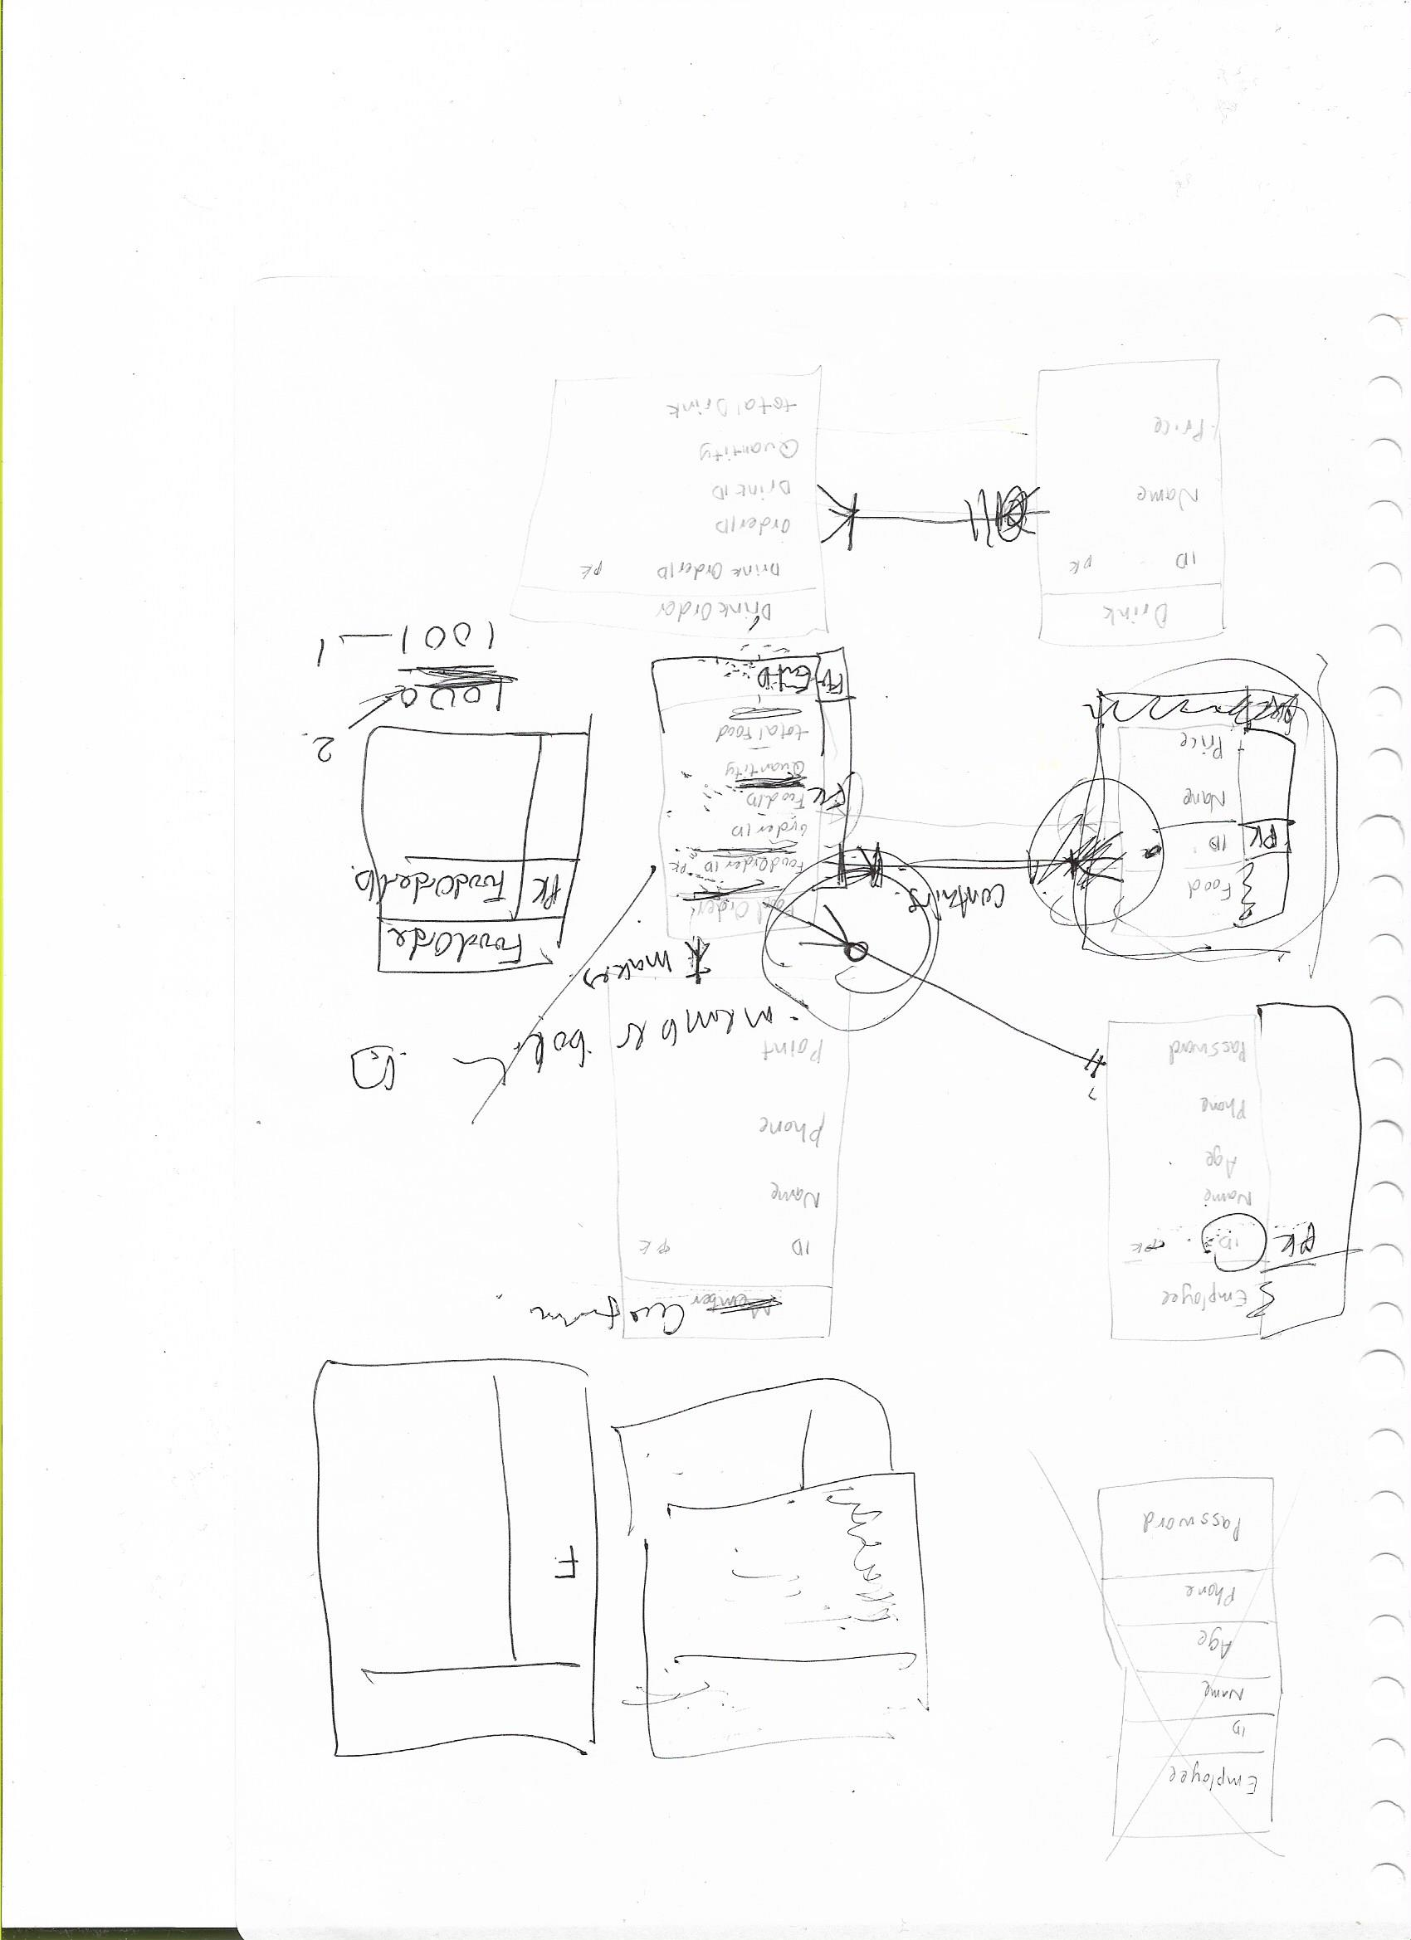

**Log Files**